School 5 Pre-K

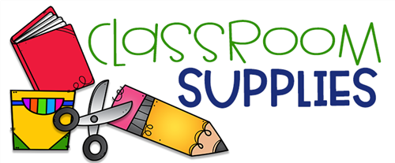

* 1 regular size backpack labeled with your child’s name
* 2 rolls of paper towels
* 1 package of Expo dry erase markers
* 1 box of 24 Crayola crayons
* 1 box of 8 ct. Crayola crayons
* 1 box of thick Crayola washable markers
* 1 box of thin Crayola washable markers
* 3 bottles of Elmer’s glue 4oz
* 1 small 3-fold or 4 -fold **plastic** nap mat
* 1 pocket folder
* 4 Elmer’s washable glue sticks (disappearing purple)
* 8 containers of 16oz Play-Doh (any color)
* 1 one subject spiral notebook
* 1 box of Kleenex tissues
* 1 pack of non-scented baby wipes
* 1box of Ziploc gallon size storage bags
* 1 box of Ziploc sandwich size storage bags
* $3.00 for heavy duty communication homework folder
* $10 for Scholastic magazine subscription to My Big World
* 1 complete change of clothes including a shirt, pants (no skirts), socks, and underwear packed in a bag labeled with your child’s name. These clothing items are necessary in the event of an accident and will be stored in the classroom.

*Supplies purchased but not listed, will be returned home.